DAA: LAB -1

1. Write a program to Print Fibonacci Series using recursion.

Program:

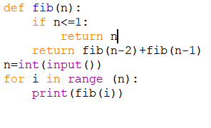

Output:

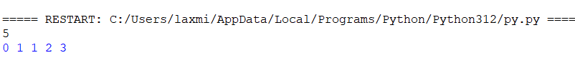

1. Write a program to check the given no is Armstrong or not using recursive function.

Program:

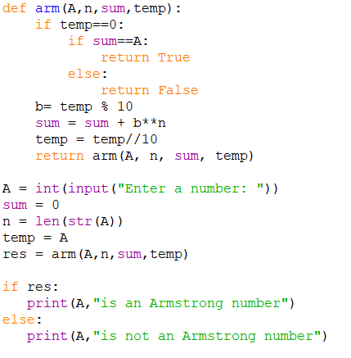

Output:

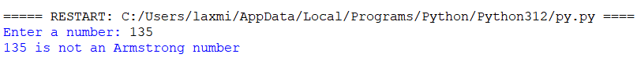

1. Write a program to find the GCD of two numbers using recursive factorization

Program:

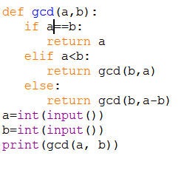

Output:

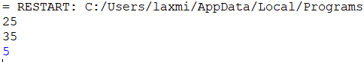

4.Write a program to get the largest element of an array.

Program:



Output:



5.Write a program to find the Factorial of a number using recursion.

Program:

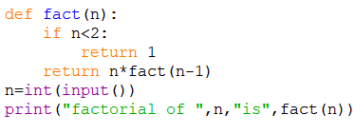

Output:

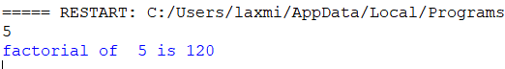

1. Write a program for to copy one string to another using recursion

Program:

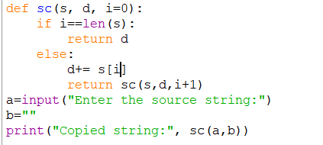

Output:

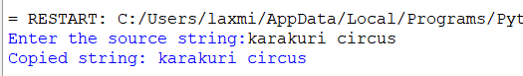

1. Write a program to print the reverse of a string using recursion

Program:

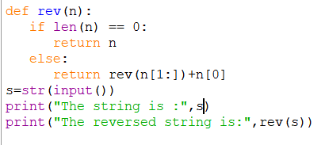

Output:

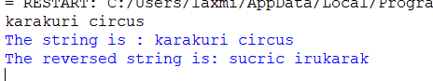

1. Write a program to generate all the prime numbers using recursion

Program:

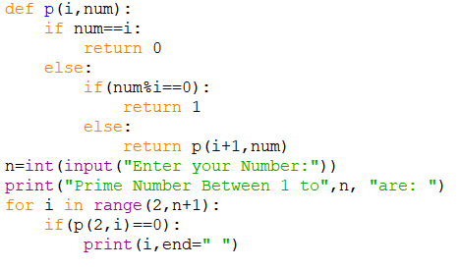

Output:



1. Write a program to check a number is a prime number or not using recursion.

Program:

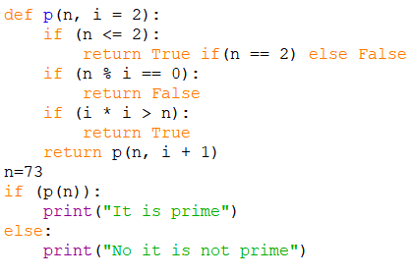

Output:



1. Write a program for to check whether a given String is Palindrome or not using recursion

Program:

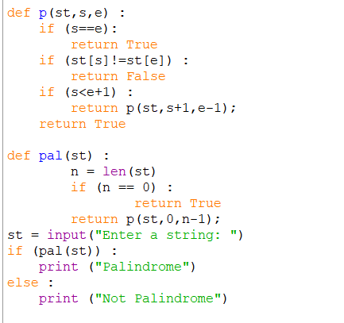

Output:

